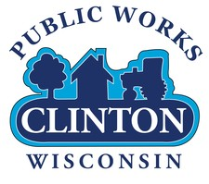

**CLINTON PUBLIC WORKS DEPARTMENT 2023 ANNUAL REPORT**

**OVERVIEW**

The Village of Clinton Encompasses about one- and one-half square miles with about twelve miles of streets, water mains and sewer mains. The population is around 2,200. The Public Works Department has four full-time employees that are responsible for maintaining the streets, water wells, water tower, water system, sanitary sewer system, sewer treatment plant, storm sewer system, parks and buildings. The following is a general review of the year for the Public Works Department.

**Public Works Operations…………………………………………..Pages 3-5**

**Water Department …………………………………………………..Pages 5-7**

**Sewer Department……………………………………………………Pages 7-8**

**Summary……………………………………………………………….….Page 9**

**Pictures…………………………………………………………………….Pages 9-11**

**PUBLIC WORKS OPERATIONS**

**Street Projects**

In 2023, street projects included Scot Drive which was re-paved with the assistance of a 50/50 grant from the State and Federal Government. The grant came after several years of applying and having the project turned down. The village did receive a local grant from the State for the project, but transferred that amount to the Westview Avenue project when the larger grant was awarded.

The curb, gutter and pavement on Scot Drive, which was originally called Atlas Avenue, was installed in 1984 after the water and sewer utilities were installed in 1983. The pavement lasting thirty-nine years was a lot longer than most streets. The paving of Scot Drive included some areas of curb and gutter replacement and the removal and replacement of blacktop from Milwaukee Street to Delco Drive and from Punzel Drive to the south end of the street. The driveway to the yard waste site was also re-paved during the Scot Drive project with an overlay of the existing pavement.

Seal Coating for the year included East Street and Ogden Avenue which were sealed using a granite aggregate, and Delco Drive using pea gravel for the heavy traffic loads that it handles. Prior to seal coating, the Public Works employees completed extensive blacktop patching on East Street. Crack filling was also done on these streets prior to the seal coating to ensure that they maintain a water tight seal which will help maintain the streets into the future.

**Clinton Crossings Subdivision**

The Clinton Crossings Subdivision kept growing in 2023, with fourteen more new homes started completing phase one of the project and getting a good start to phase two. We will be having discussions in 2024 about phase three, the final phase of the subdivision.

**Building Permits**

There were 94 permits taken out in 2023. As mentioned above, 14 of those permits was for new home construction and one permit was for a new commercial storage building. The remainder consisted primarily of remodeling, roofing, fences, windows and siding.

The permit fees for all permits issued totaled $35,065.39. The total project cost valuation for these permits was $3,295,463.00.

We renewed our contract with the company Iworq which is the management program for building inspection, but discontinued the program for code enforcement. The program is an internet-based system.

**Refuse and Recycling**

Our contract with Badgerland Disposal (LRS) was set to expire on February 28, 2024, so we sent out a request for proposals for refuse and recycling pick up to all the contractors in this area. LRS, having the lowest proposal for the pick up of refuse and recycling, was awarded the five-year contract. A change in the new contract with LRS provided that they pick up electronics items and tires (off the rim) at the yard waste site on Scot Drive during the once per month large item pick up.

The new contract with LRS will run from March 1, 2024 through February 28, 2029. Starting in 2024, the cost for pick up will be a total of $14.50 per household and ending in 2029 at a cost of $16.32 per household per month. Current households in Clinton total seven hundred and forty-five.

**Parks**

In 2023, the Public Works Department removed all the play equipment from the old Heldt Paulson Park which is now the Clinton Crossings subdivision. Unfortunately, most of the park equipment was unable to be saved as there was just too much cement attached to the equipment. What was saved, will be used in the new park which will be located at the west end of the new subdivision.

A new set of play equipment was ordered for Gert Walter Park in fall. The equipment was delivered and installation will take place sometime in the Spring of 2024.

**Tree City**

Once again, the Village of Clinton achieved Tree City Status for the twenty-first year. The Arbor Day tree planting took place at the Senior Center with a tree planting in Memory of Harry Crusan, a veteran and member of the VFW and American Legion.

**__________________________________________________________**

**WATER DEPARTMENT**

**Water Usage**

In 2023 the Water Department pumped 76,321,000 gallons of water with 50,259,300 gallons being sold. The difference includes various other uses of water such as flushing hydrants and pre-lubrication of the well. We have found that a rather large leak is indicated by the usage compared to the pumpage. We have been actively looking for a leak in the system which could be the result of several different issues. This could be an actual leak in the water system although we have not been able to confirm that yet, it could be a problem with the water meters or the programing for them, or it could be an error in the water utility billing system. The leak seems to be about the same amount from month to moth which could indicate a programming issue. We will be continuing to work on this problem through 2024 including hiring a leak detection company.

**Well and Tower Operation**

Well number three. next to the water tower on Delco Drive, has been operating with no issues this year. The well will be due for a standard checkup in another year to check for ware on the well pump and shaft.

Well number four has also been working well since its pump and shaft replacement in 2022. This well will go for several years yet before it needs to have the well pump and shaft check, providing we have no issue with it in the meantime.

The water tower was inspected and cleaned twice this year to pump out all the iron sludge that settles in the bottom of the tower. Without the cleaning, on windy days or times when fire hydrants are used, the iron runs from the tower to the mains and the complaints begin.

The installation of the filters at well number three will cut the iron problem in half. When it becomes financially acceptable, well number four should also have filters or other means installed to remove iron.

**Water Construction Project**

The water main construction from Milwaukee Street to the new subdivision was completed this year at a cost which was under budget. The original bid for the water project was awarded at $165,718.00 and was completed at a cost of $141,925.00.

The completion of the water main project brings twelve-inch water main from well number four all the way through the new subdivision to Milwaukee Street and connects to a ten-inch water main that runs to the water tower on Delco Drive.

**Well #3 Filter and Filter Building Project**

The construction of the filter building at well number three suffered a setback this year with the Village not being able to secure the Clean Water Fund loan that will be necessary for the construction.

The Village Engineer is working toward ensuring that in 2024 we will be able to receive the Clean Water Fund Loan which will allow us to have up to a 25% loan forgiveness for the project.

**Lead Service Identification**

The Department of Natural Resources along with the Environmental Protection Agency, have require the Water Department to identify lead piping that exists in our water system and services along with the customer side of the water service.

A report must be submitted to them by October 24, 2024 along with an action plan on what we plan to do to mitigate the lead issue. We have been working to identify as much of the system and services as possible. We will be receiving help with this project in 2024 from a grant that will allow us to use an engineering firm from Chicago to go through our records and help with the report and determine our plan forward.

**Water Main Breaks**

The number of water main breaks in Clinton has remain low in 2023 as it has in prior years. There were three water main breaks, one on High Street near Allen Street, on Westview near Meadow Park Drive and in the 200 block of East Street. The leak on Meadow Park Drive was actually a fire hydrant valve that had bolts rust off of it. The break on East Street was a six-inch line that was poorly backfilled when they installed in the mid 1980’s. Large rocks around the pipe eventually wore through and caused the break. The portion of main on East Street that has bad fill around it will be replaced in 2024 during the street project.

**__________________________________________________________**

**SEWER DEPARTMENT**

**Sewer Plant Operation**

The sewer plant operated well again in 2023 without any major repairs need to continue operation. Other than some high influent biochemical oxygen demand, the plant stayed within the Department of Natural Resources limits required by the Wisconsin Pollution Discharge Elimination System permit (WPDES).

The five-year WPDES permit will be expiring at the end of 2024 so we will be working on the application for the new permit. During this permit process, the DNR will inform us of any changes we may need to make in out plant operation.

Flows into the sewer plant were at 81,469,000 for the year. This flow is up about 50-60% from recent previous years due to the rain in 2023. Previous recent years have lacked enough rain the cause a lot of intrusion into the sewer collection system. As we conclude the cleaning and televising of the entire sewer collection system, we will begin to look at sewer main lining to reduce the amount of clear water intrusion into the sewer system. Lining of the mains consists of installing a plastic liner inside of the existing sewer lines. This process is much cheaper than the actual replacement of the lines itself. We have already installed a plastic liner in the sewer main on Highland Park Avenue a few years ago.

There were no sewer main back ups during they year which resulted in any damage to homes or businesses within the village.

**Sewer System Construction**

The construction of sewer main to the new subdivision was slowed down by the discovery of limestone near and under Milwaukee Street by the Railroad Tracks. This issue not only prevented the completion of the project in 2022, it also added to the cost of the project.

The original bid for the sewer project to the subdivision was accepted at $292,677.50. With the need for special equipment to deal with the limestone, the total cost of the project ended at $445,026.25. The sewer project was necessary because a lift station will be needed for phase three of the subdivision project and will also cover a larger area for future expansion.

**SUMMARY**

In 2023, the Public Works Department was involved in the repaving and seal coating of streets, the new installation of water and sewer mains, and the general maintenance and repairs necessary for all the aspects of the department.

Water quality remained good with no contaminants detected that effect the water in the wells or throughout the water system. The Public Works Department is working toward filtering the iron and manganese out of the water.

The Sewer Treatment Facility continues to meet all of its requirements while the sewer system is being inspected for future repairs to reduce the inflow.

**__________________________________________________________**

**Some Pictures of Events During the Year**

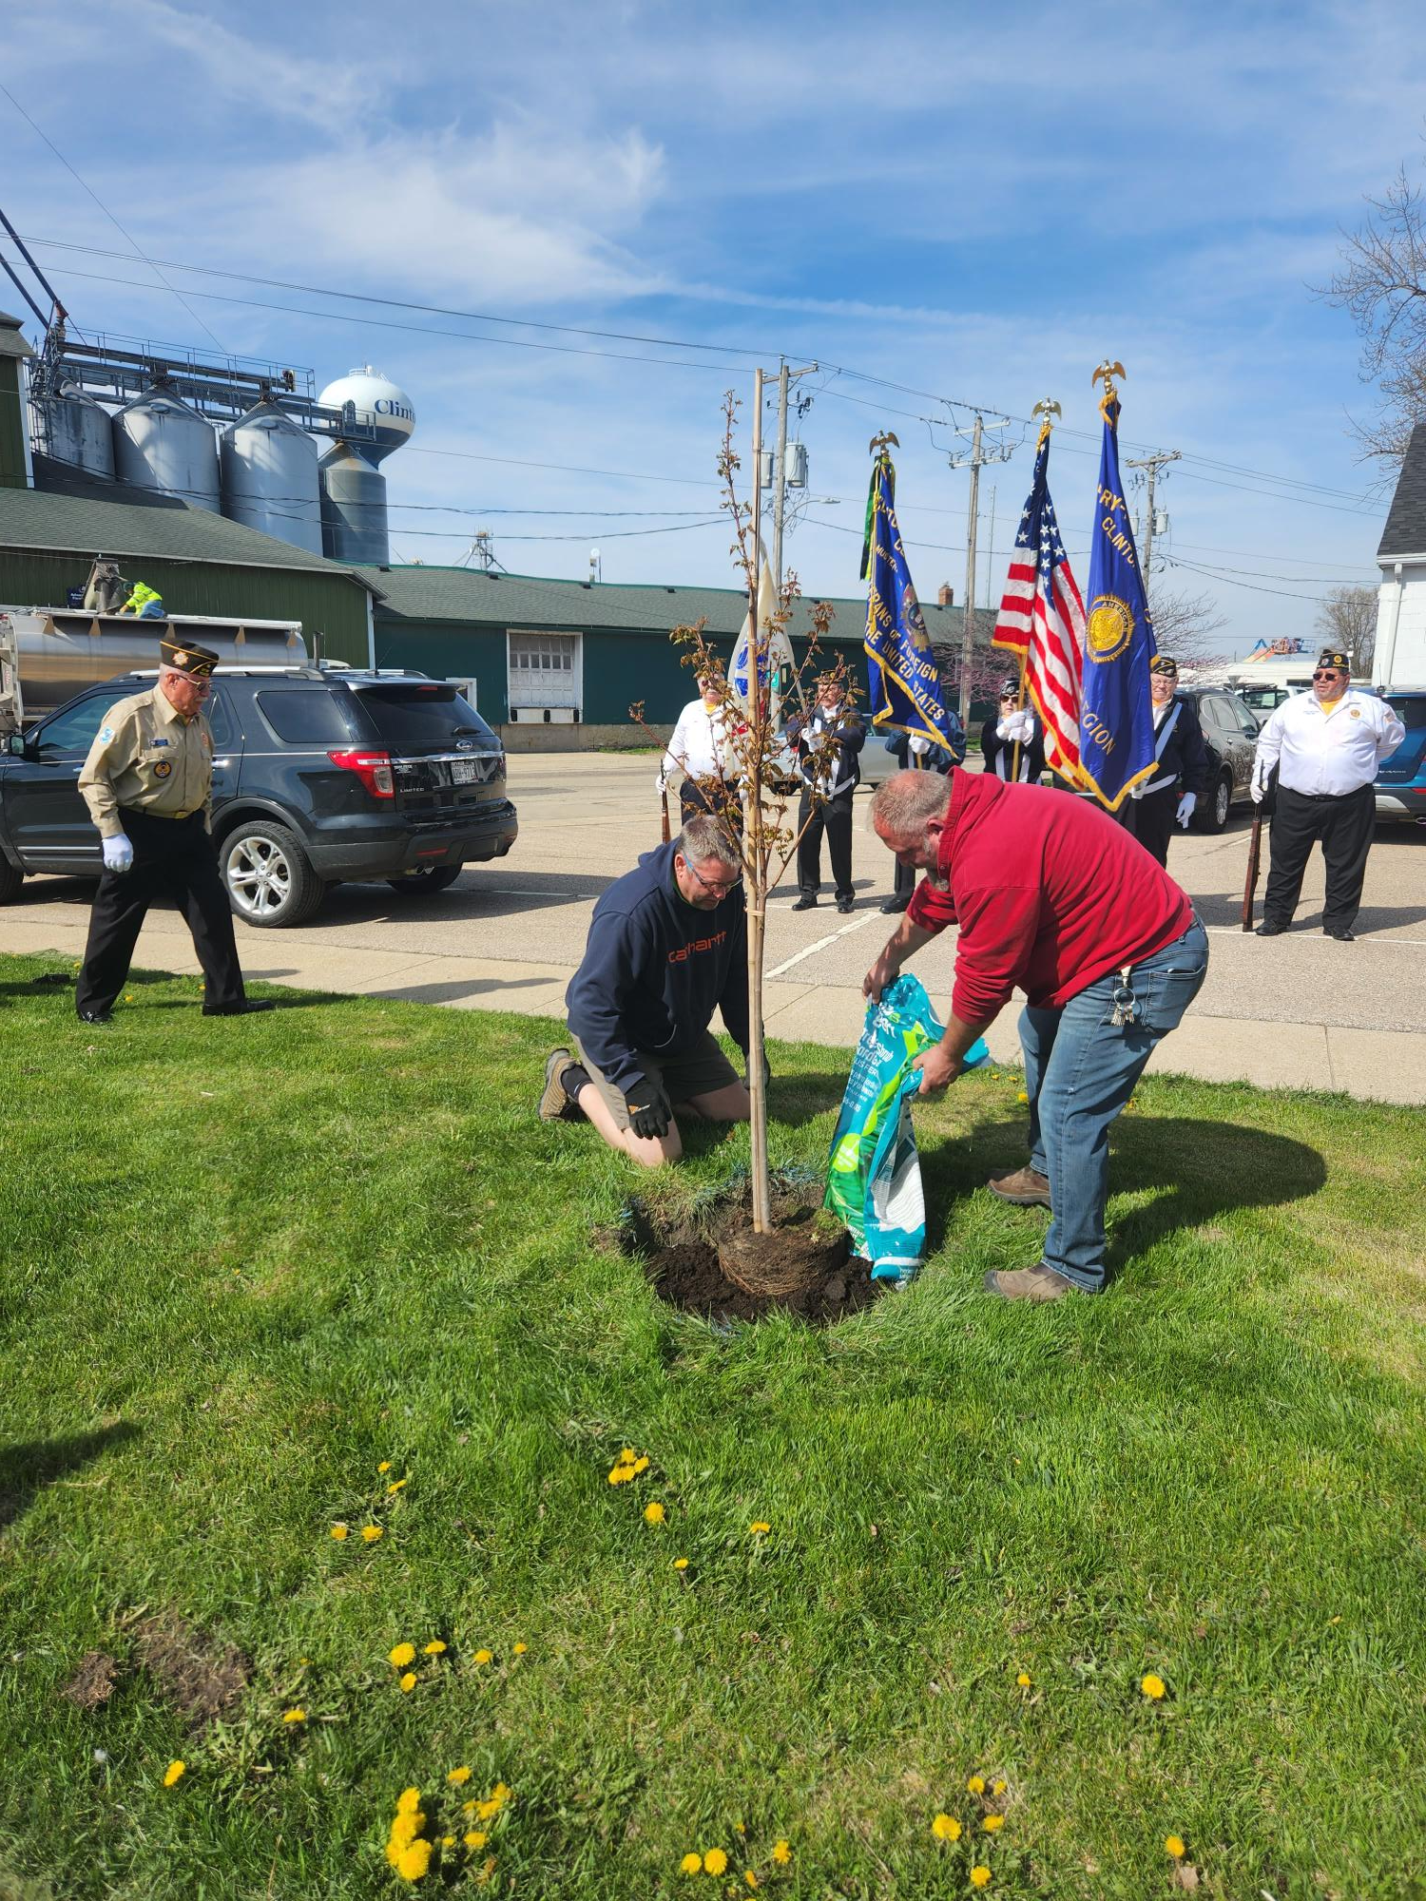

Arbor Day Event Tree Planting at Clinton VFW, Legion, and Senior Center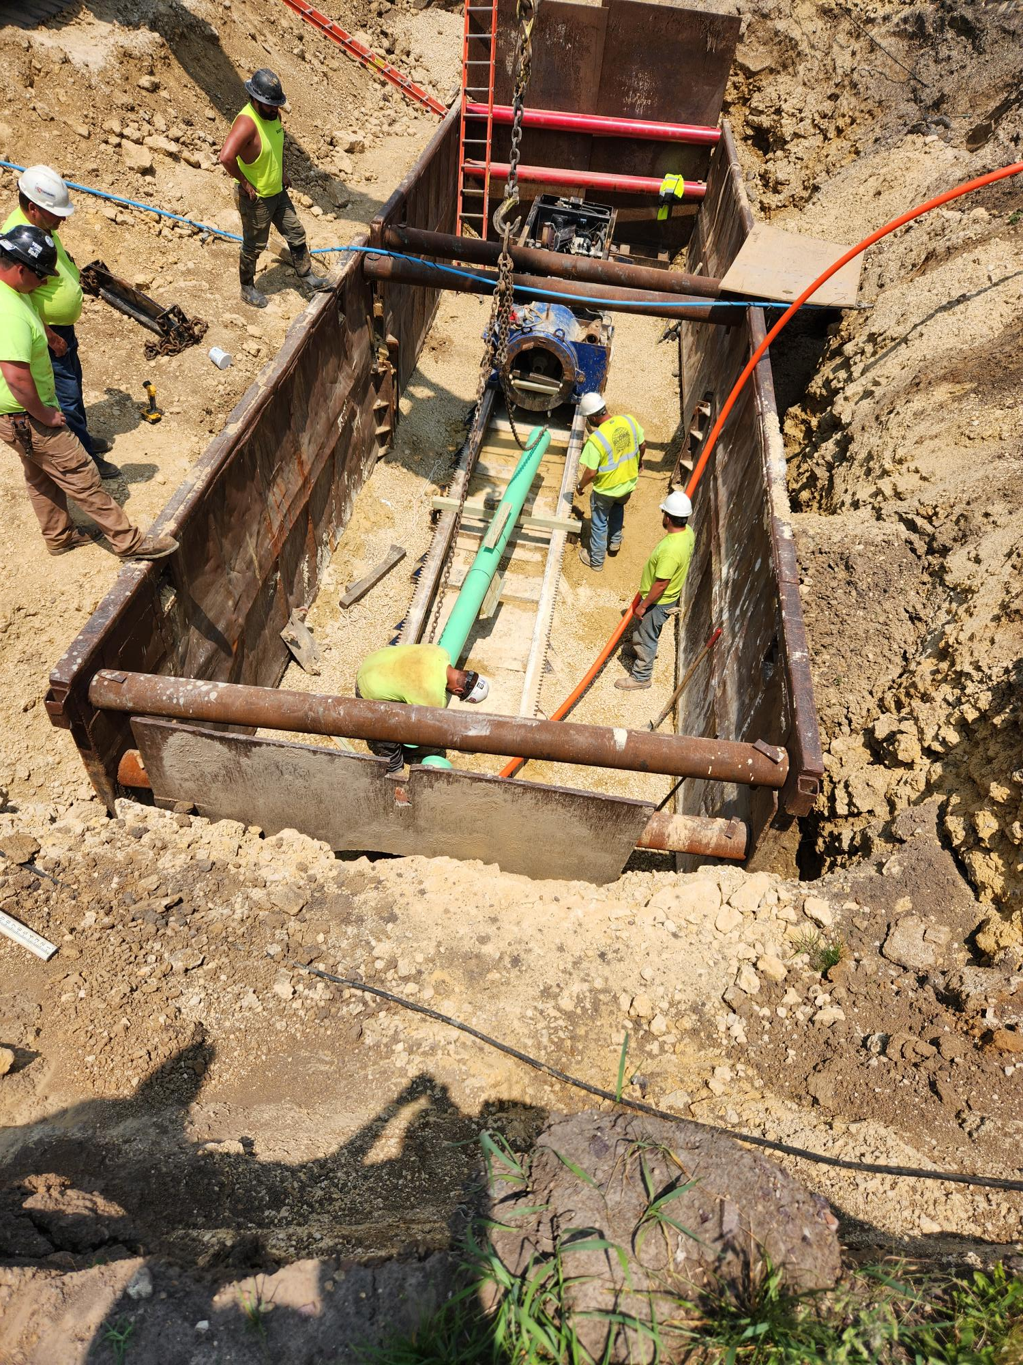

Boring Sewer Main through Limestone under the RR tracks on Milwaukee Street

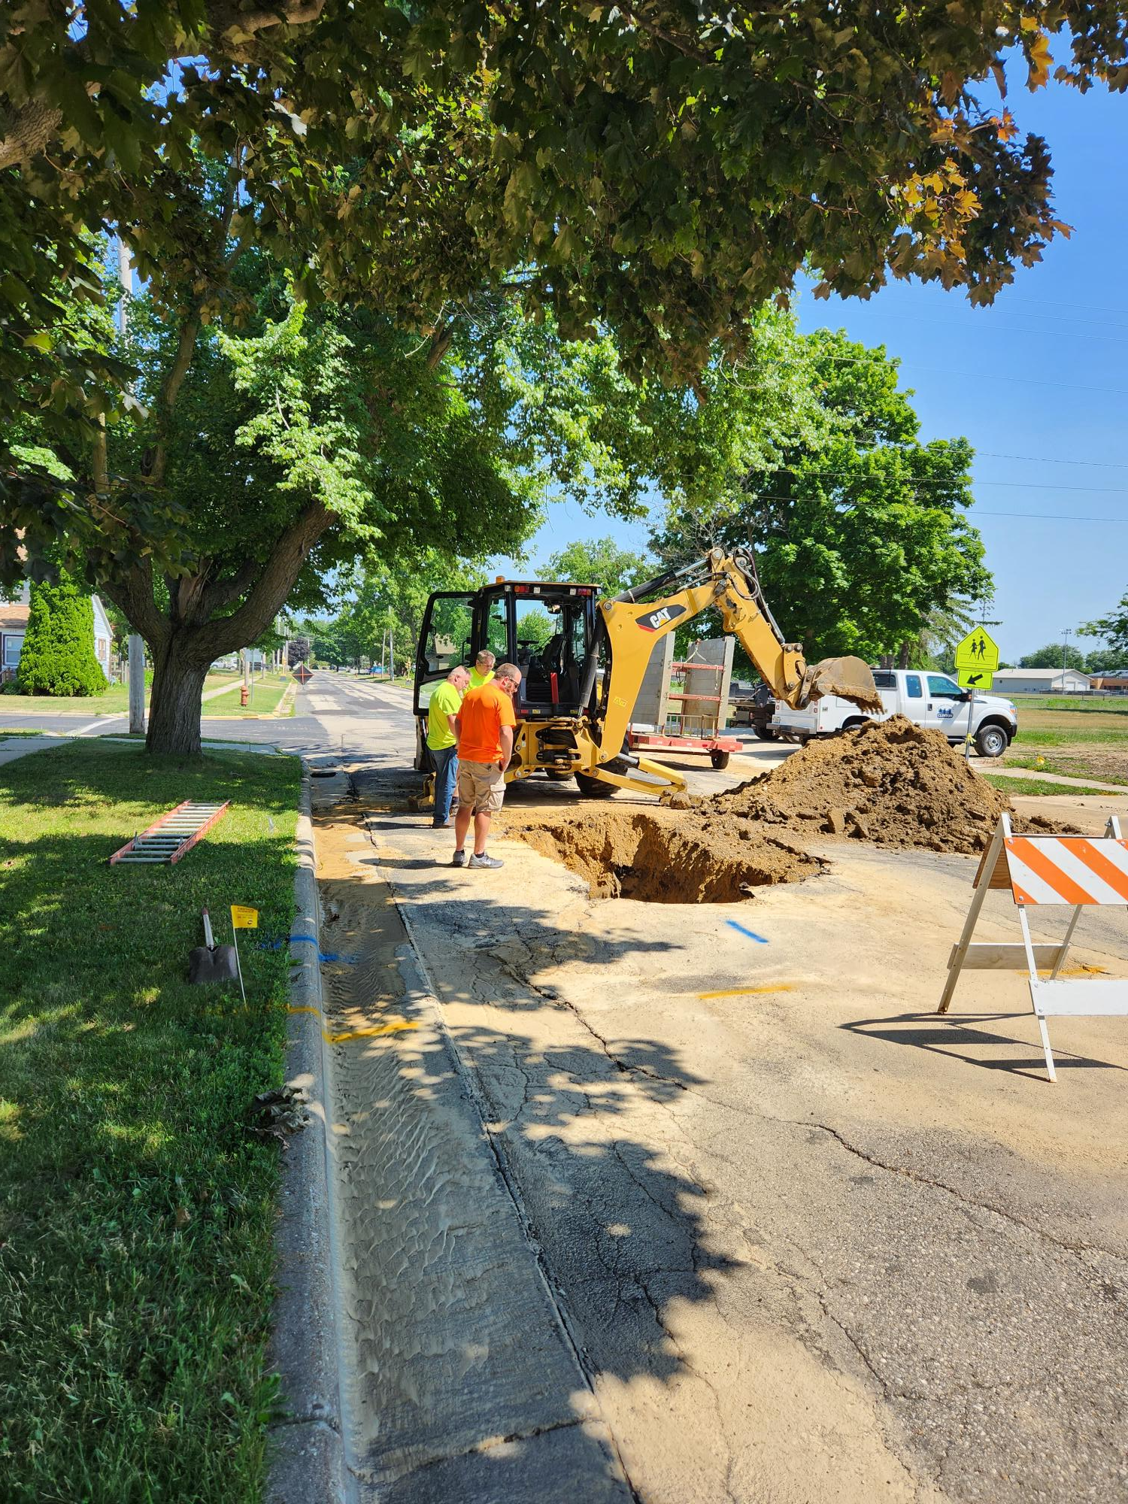

Public Works Employees Repairing Water main break on East Street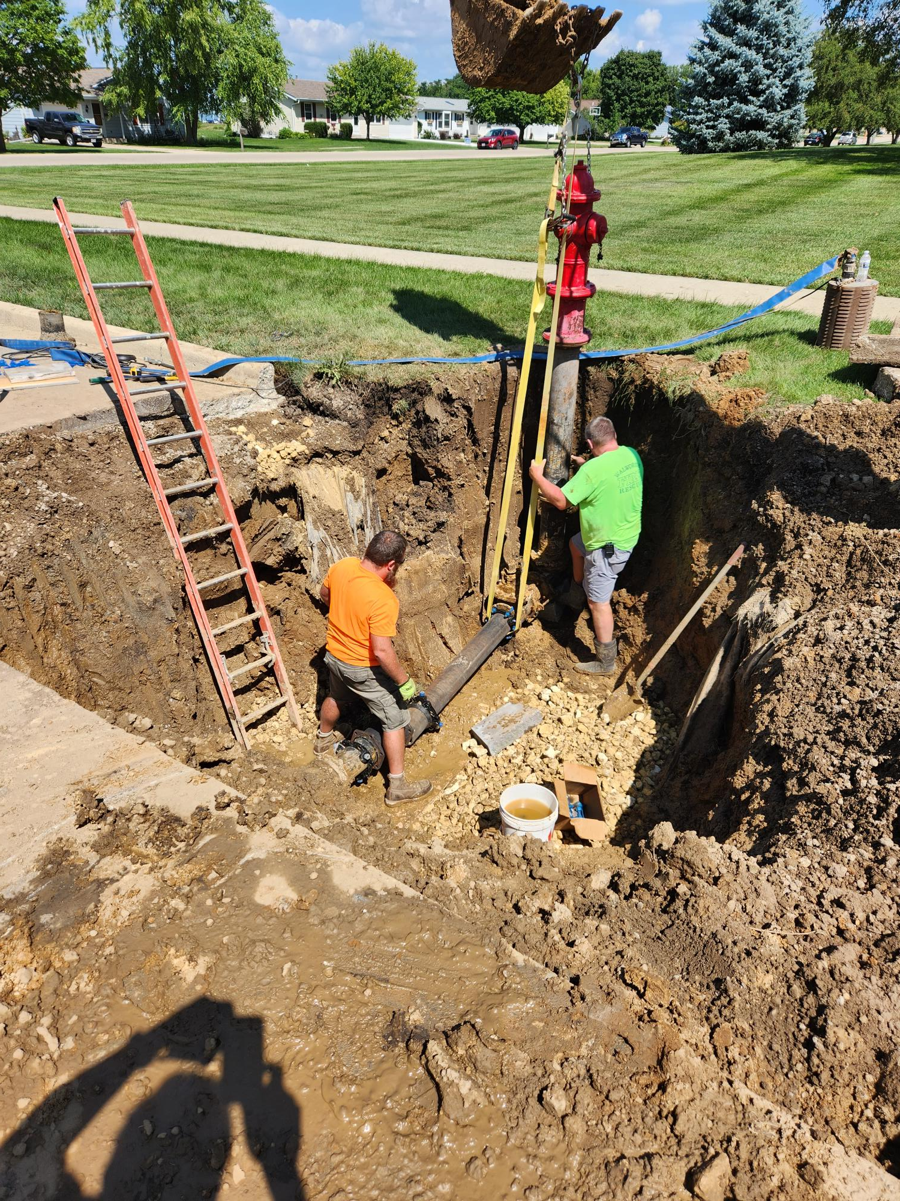Public Works Employees Installing a new hydrant where hydrant valve failed Westview Avenue

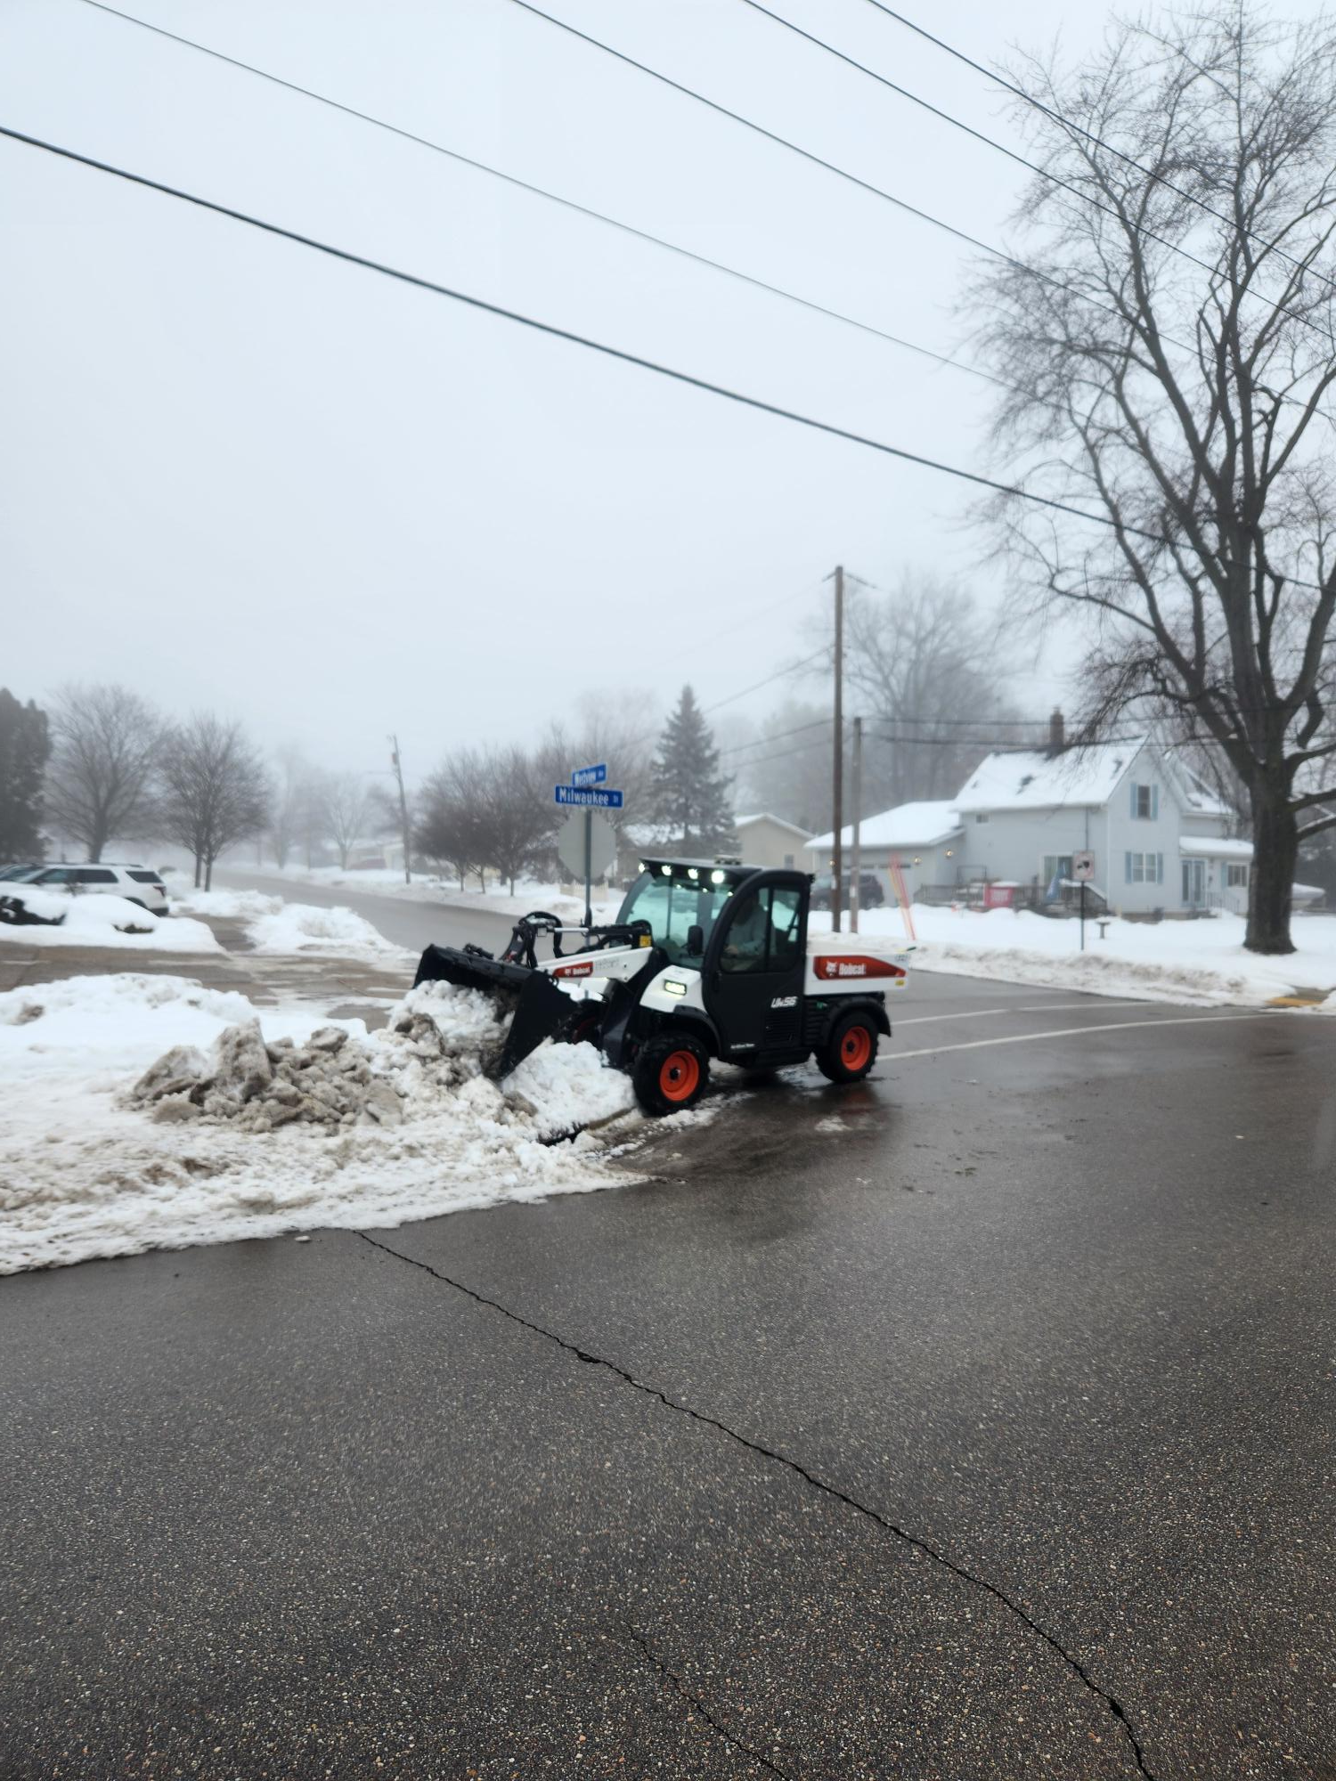

Public Works Snow Removal Operation with DPW Tool Cat - 2023